Screening of Fungi from Oil Palm Rhizosphere in Peat Soils and the Potential as Biological Agents against Ganoderma boninense
Fifi Puspita, Isna Rahma Dini*, and Dermala Sari
Department of Agrotechnology, Faculty of Agriculture, Universitas Riau, Indonesia
Abstract. One of the diseases that attack oil palm plants is stem rot disease. Control efforts that can be done is to use rhizosphere fungi from oil palm plants in peat soils. This study aimed to select fungi from rhizosphere of oil palm plants in peat soil based on morphological characteristics and test their potential as biological agents against Ganoderma boninense. This research was conducted by exploration, observation and experiment by using complete randomized design (RAL). The parameters observed were macroscopic characteristics of fungi from oil palm rhizosphere, disease severity index, fungus inhibition power from oil palm rhizosphere to G. boninense, colony diameter and growth rate of high antagonist rhizosphere fungus, hyperparasitic type of fungus from rhizosphere of oil palm plant with G. boninense and the morphological characteristics of fungi from high antagonist rhizosphere in macroscopic and microscopic. The results showed that 12 rhizosphere fungi isolates and 4 isolates were antagonist to G. boninense. Isolate J5 has a high antagonist power of 70.26% and is a genus Trichoderma, isolate J7 belongs to the genus Trichoderma, isolate J10 genus Aspergillus and isolate J12 genus Mucor.

Keywords: fungi, oil palm, rizosphere, screening

Received 5 April 2019 | Revised 15 August 2019 | Accepted 26 August 2019

Introduction

Oil palm (Elaeis guineensis Jacq.) is one of the plantation crops in Indonesia which has a high economic value. The area of oil palm plantations in Indonesia in 2016 reached 12 million ha [1]. Oil palm plantations have spread in several provinces in Indonesia, one of the Riau Province. Oil palm plantations in Riau Province has increased from year to year. Extensive oil palm plantations in 2007 reached 1,612,382 ha with total production of 1,739,855 tons, in 2010 reached 1,932,762 ha with total production of 2,636,432 tons in 2013 reached 2,193,721 ha with a production of 6,646,997 tons and in 2016 continued to increase reaching 2,400,876 ha, with a total production of 8,059,846 tons [2]. Oil palm in Riau Province was planted in the 1990 and most of the final stages of the production cycle that needs to be planned replanting activities.

Replanting is done by clearing the palm trees are no longer productive in the area of land. Activity oil palm replanting must be done carefully, so that no occurrence of a problem for the future. Problems faced when replanting of oil palm without sanitation, where the roots or tubers of plants left behind, which can potentially a source of inoculum from plant diseases.

One of the important disease in oil palm plantation is stem rot disease. Stem rot disease consists of 2 disease are basal stem rot (BSR) and the upper stem rot (USR). According to data from the [2] G. boninense have attacked oil palm plantations covering an area of 533.8 hectares and the largest is the Kampar District was 211 ha. The attack G. boninense. oil palm plantations necessary control measures.

Control is done only on BSR diseases, one of them with biological control. [3] stated that the highest percentage of inhibition in vitro was Trichoderma sp. by 100% against G. boninense. BSR is the cause of the diseases nor the USR, so that biological control can also be used to control it. The effort to control it was utilize fungi origin in oil palm rhizosphere on peat soil. The origin fungi in oil palm rhizosphere to be effective in controlling the USR diseases, as the host of G. boninense. is a lot of palm trees planted in peat soils. Fungi rhizosphere be around the roots of plants. This is because the roots of plants that grow will result in root exudates in the form of water or soluble compounds such as sugars and organic acids which are useful as nutrients for fungi.

The origin fungi in oil palm rhizosphere on peat soil can suppress the development of plant pathogens [4]. The mechanism controlling fungi antagonis to pathogen fungi is directly and indirectly. Indirectly such as induce systemic resistance and Plant Growth Promoting Fungi (PGPF). PGPF found around the roots of healthy plants grown cultivation and wild plants [5].

Biological control for plant pathogen such as Ganoderma needs to be explored, isolation, and identification of potential test. Isolation origin fungi in oil palm rhizosphere potential in controlling G. boninense. because it can be associated, grow and develop in an environment of relatively. This study purposed to select the origin fungi rhizosphere in oil palm on peat soils based on morphological characteristics, and test its potential as a biological agent against G. boninense.

Methods

This research was conducted at the Laboratory of Plant Pathology, Faculty of Agriculture, Universitas Riau. It was conducted for three months from December 2017 to February 2018. Materials used in this research was the origin of the rhizosphere soil plant oil palm plantation in Rimbo Panjang Riau, G. boninense. isolate from the collection of industrial business unit Biofertilizer and Biofungisida derived from palm trees showing symptoms of USR in oil palm plantations, cucumber seeds, potato dextrose agar (PDA), 2% water agar, spritus, amoxiciilin, tissue, 70% alcohol, water distilled sterile, aluminum foil, plastic warp and graph paper.

The research was conducted in exploration, observation and experimentation. The antagonist test from the origin of the rhizosphere soil plant oil palm done using a completely randomized design (CRD), which consisted of 9 treatments and 3 replications thus obtained 27 experimental units. Growth test in antagonist fungi done using a completely randomized design (CRD), which consists of 4 treatments and 5 replications, in order to obtain 20 experimental units. The results of further tests of honestly significant differences (HSD) at the 5% level.

Implementation of the study consisted of isolation of fungal origin rhizosphere oil palm plantations, purification of fungal origin rhizosphere of oil palm, rejuvenation isolate G. boninense, hypovirulence test, test of antagonists fungal origin rhizosphere plant oil palm on G. boninense., the growth of fungus origin rhizosphere oil palm defenseless antagonist high against G. boninense, hyperparasitis test of 4 fungal isolates rhizosphere palm trees defenseless antagonist high against G. boninense, identification of fungal origin rhizosphere oil palm plantations helpless antagonist high based on morphological characteristics and observation.
  - Disease Severity Index (DSI) in the Hypovirulence Test

Hypovirulence test observations were made by observing the disease severity index (DSI) following from [6]. How to calculate DSI is based on the following formula:
DSI = (Σ N) / Z

Where:
DSI = Disease Severity Index

N = Value of disease severity of each seed

Z = Number of seeds used

Disease severity values are measured according to the scale below:

0 = Healthy and no spotting on hypocotyl

1 = One or two light brown patches (light) <0.25 cm

2 = Light brown patches (size 0.25-0.5 cm) and wet area <10% on hypocotyl

3 = Light brown spots (young) to dark (old) > 1.0 cm and later Join with other spots and wet areas on hypocotyl 10-100% (leaves are still tough and white)

4 = hypocotyl fall, leaves wilt and die
  - Inhibition of Fungus Origin from Rhizosphere of Oil Palm Plantations in Peat Soil against the Fungus G. boninense

Observation of fungal inhibition of peat rhizosphere origin on G. boninense performed from day 3 after incubation until one of the mycelium fungi meets a petri dish containing a PDA. after incubation by measuring the radius of pathogen G. boninense which moves away from and approaches the antagonistic fungus using millimeter paper.

The percentage of inhibition is calculated by the following formula:
P = $\frac{\text{r}\text{1 }\text{- r}\text{2}}{\text{r}\text{1}}$ x 100% (1)

Note :

P = Percentage of obstacles (%)

r1 = Distance between mushrooms of G. boninense away from antagonistic fungi (mm) (calculated from the center of the growing point)

r2 = Distance between mushrooms of G. boninense which approaches the antagonistic fungus (mm)

If the inhibition is> 60%, the antagonistic fungus has the potential to become a biological agent [7].

Results and Discussion
  - Fungi macroscopic characteristics in the rhizosphere of oil palm
The result of exploration was obtained 12 fungi isolates the rhizosphere of oil palm. The characteristics of macroscopic morphology fungi on Table 1 and Figure 4.
Table 1. Characteristics of Macroscopic Fungi Origin in Oil Palm Rhizosphere
Isolates | Forms colonies |  |  | The colony colour
 | Above | Edge | Elevation
J1 | round | smooth | Flat | grey with white edge
J2 | concentric | smooth | Flat | Green
J3 | round | ramified | Arise | White
J4 | round | Smooth | Flat | white chocolate
J5 | concentric | Smooth | Flat | greenish white
J6 | round with raised edge | irregular | Umbonat | White
J7 | concentric | Smooth | Flat | greenish white
J8 | round with raised edge | Surging | Arise | Beige
J9 | round | Smooth | flat | amid white yellow
J10 | round | Smooth | flat | brownish green with white edge
J11 | round | Smooth | Flat | White
J12 | round | ramified | Arise | brown with white edge
Figure 1 shows that rhizosphere fungal isolates from oil palm plants in isolated peat soils have morphological characteristics that differ in color, colony surface and spread of growth. This is presumably because the rhizosphere fungi of oil palm plants have different genera and species. This is supported by the opinion of [5] which stated that the fungus group consists of, namely Zygomycetes, Ascomycetes, Basidiomycetes and Deuteromycetes.
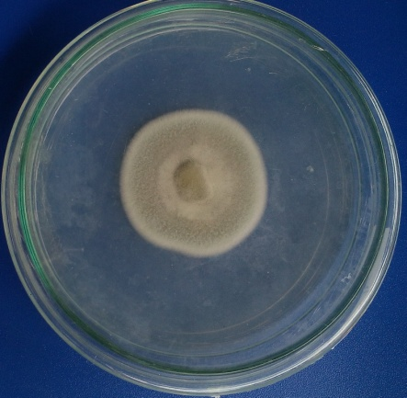  J1 | 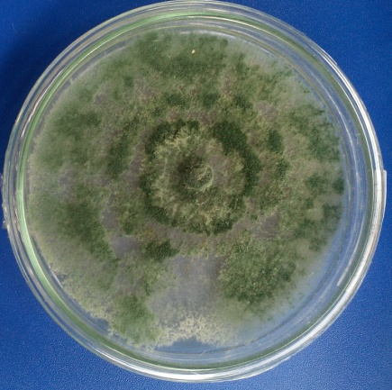  J2  2 | 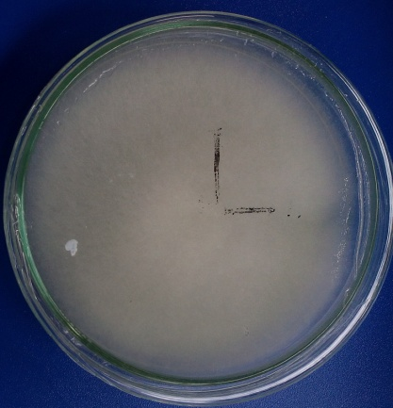  J3
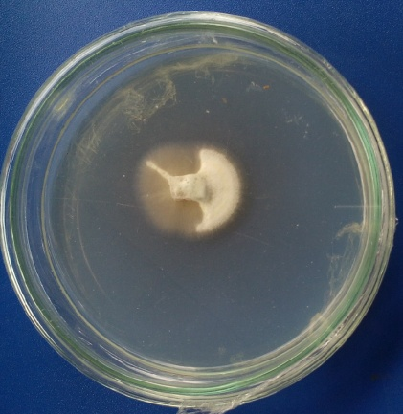 | 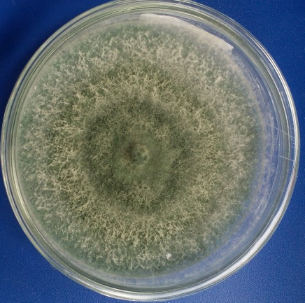  J5  J4 | 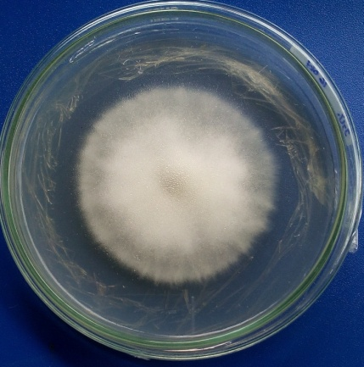  J6  6
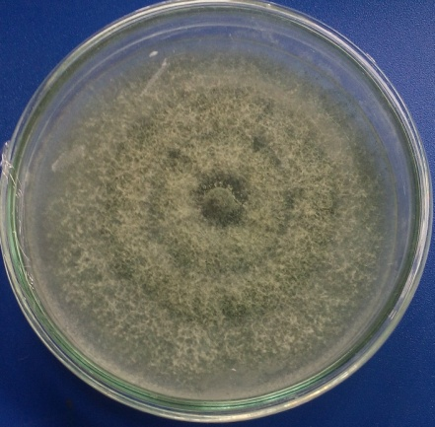  J7 | 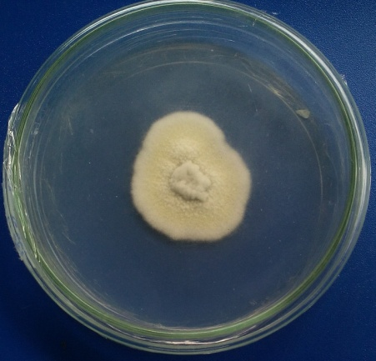  J8 | 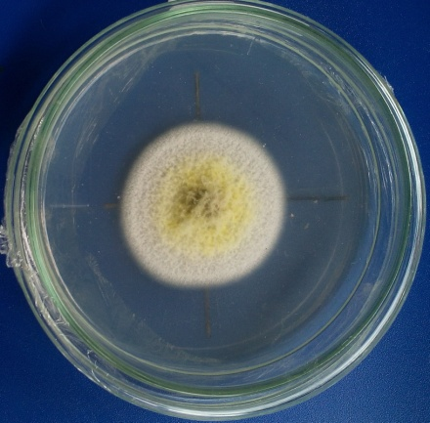  J9
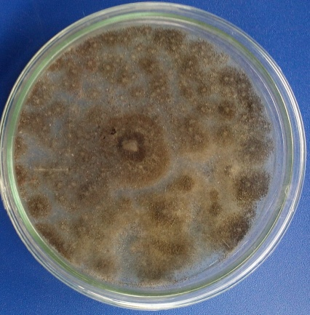  J10  J11  J12 | 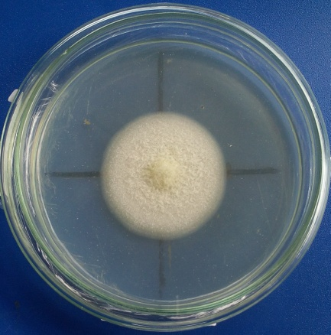 | 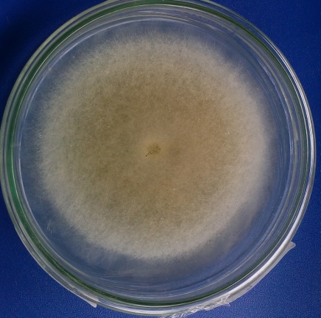

Figure 1. Isolates Fungi from Oil Palm Rhizosphere in PDA 7 Days after Incubation (DAI)

  - Disease Severity Index (Disease Severity Index / DSI) in Test Hypovirulence
The disease severity index of 12 rhizosphere fungi isolates from rhizosphere in oil palm on Table 2.
Table 2. Disease Severity Index of 12 Fungal Isolates from Rhizosphere in Oil Palm
Isolates | DSI | Category
J1  J2  J3  J4  J5  J6  J7  J8  J9  J10  J11  J12 | 2.5  0.5  3.5  4  0.5  1.5  0.5  1.5  3  1  1.5  1 | not hypovirulence  Hypovirulence  not hypovirulence  not hypovirulence  Hypovirulence  Hypovirulence  Hypovirulence  Hypovirulence  not hypovirulence  Hypovirulence  Hypovirulence  Hypovirulence

Table 2 showed that of the 12 isolates tested, obtained eight isolates with code J2, J5, J6, J7, J8, J10, J11 and J12, which can be categorized into hypovirulence pathogenic fungi and 4 isolates with code J1, J3, J4 and J9 into not hypovirulence (non pathogen) fungi. The hypovirulence (pathogen fungi) has a value of DSI <2 is only symptomatic sized brown spots <0.5 cm and wetness area <10% in cucumber seedling hypocotyls. This is presumably because the fungal isolates have a low level of virulence of the cucumber seedlings. This is supported by research results [6] stated that hypovirulence fungus is soil fungi infect plants have the ability to lower and can grow together with the growth of plants and can be used as an agent antagonist.
  - Inhibitory Power Plant Rhizosphere Fungus Origin Palm Against G. boninense
Table 3. Power Resistor Rhizosphere Fungi Hypovirulence Oil Palm Against G. boninense.
Isolates | Inhibition (%)
Without treatment (J0)  J8  J6  J11  J2  J12  J10  J7  J5 | 0.00 d  33.33 c  38.49 bc  48.15 bc  48.96 bc  63.33 ab  66.94 ab  67.83 ab  70.26 a
The numbers followed by the same small letter is not significant according to the results of a further test honestly significant difference (HSD) at 5% level after arcsin transformed √Y + 0.5

The inhibitory power of eight rhizosphere fungi isolates from hypovirulence oil palm plants has different percentage of resistance to G. boninense. after analyzing variance. of the rhizosphere fungal inhibitory power can be seen in Table 3. Table 3 shows that isolate J5 have inhibitory tends to be high, namely 70.26% and no significant isolates J7, J10, and J12, but significantly different from the isolates J2, J6, J11, J8 and without treatment. This is presumably because J5 isolates have faster growth and can be seen in the measurement parameters diameter and speed of growth, where the nutrients that should be used by G. boninense, But was used by the rhizosphere fungi. [8] [7] stated that the fast-growing fungus is able to outperform in the control room and in the end could suppress the growth of fungi opponent. 4 antagonist assay results rhizosphere fungal isolates high-powered antagonists against G. boninense can be seen in Figure 2.
G
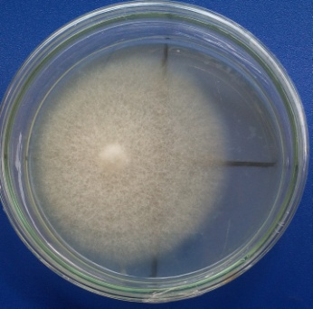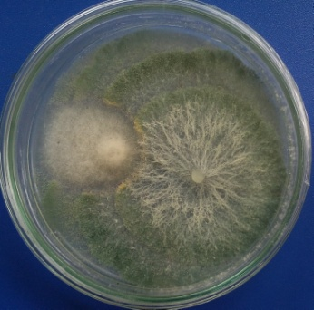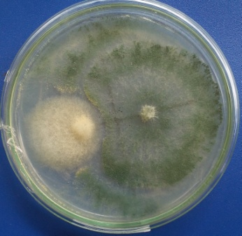
G
G
c
b
a

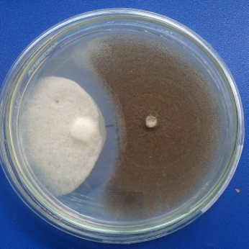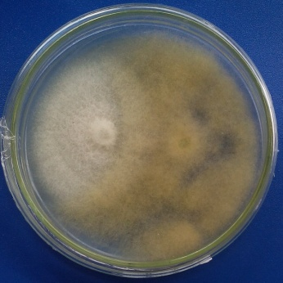
e
Z
d
Figure 2. Power 4 Fungal Isolates Antagonist Rhizosphere Origin Peat Against G. boninense. Reviewed PDA mendium 6 days after incubation (HSI). a) non-treated fungal isolates the rhizosphere, b) isolates J5, c) isolates J7, d) isolates J10, e) isolates J12, Z = Zone of Inhibition and G = G. boninense.

Figure 2 shows that the fungal antagonist (isolates J5, J7, J10 and J12) over control of the room grow on PDA medium compared G. boninense. This is presumably because the rhizosphere fungi capable of competing space to grow, so take advantage of the growing medium as a source of food for fungal pathogens antagonist and both need nutrients to grow. [9] stated that the rate of growth of the fungus high antagonist activity in suppressing pathogen determine the competition space and nutrients.

J5 and J7 isolates also showed inhibition zones, namely the change in color to the antagonist fungus hyphae-hyphae that at the end of fungal hyphae G. boninense. This is presumably because the antagonist fungi secrete an antibiotic substance capable of inhibiting the growth and development of G. boninense. According to [10], biological agents produces secondary metabolites that function as antibiotics, namely dermadin and gliotoxin.

J10 isolates also showed inhibition zone on the test antagonist marked by a clear coat at a meeting of fungal mycelium antagonist and G. boninense. This is presumably because the fungal isolates produce antibiotic substances, so terbetuknya clear zone. This is supported by research results [11] which stated that the mechanism of antibiosis shown by the formation of zones of inhibition of fungal growth. Zone of inhibition is a form of interaction of microorganisms antagonist adverse effect on other microorganisms [12].
  - Diameter Colonies and Fungus Growth Speed Rhizosphere Antagonists which Helpless Height (mm/day)
The results of rhizosphere fungi isolates with high antagonist properties resulted in different colony diameter and growth velocity after being analyzed by variance. The results of further tests are the smallest significant difference at the 5% level of the measurement of diameter and growth velocity can be seen in Table 4.
Table 4. Results of the Measurement of the Diameter and Speed of Growth of the Fungus Rhizosphere High-Powered Antagonists
Isolates | Diameter (mm) | Growth speed (mm / day)
J10  J12  J7  J5 | 44.40 d  60.40 c  84.00 b  92,30 a | 6,10 c  11.50 bc  12.70 b  19.60 a
The numbers followed by the same small letter is not significant according to the results of a further test least significant difference (LSD) at 5%

Table 4 shows that isolate J5 has a diameter and the highest growth rate reaching 92.30 mm and 19.60 mm and significantly different from the 3 other isolates that J7 (84.00 mm and 12.70 mm), J12 (60.40 mm and 11.50 mm) and J10 (44.40 mm and 6.10 mm). J5 isolates growth very quickly so as to meet the growing space on the fourth day of observation. This is related to the results of the rhizosphere fungi antagonist power capable of competing in the race for space and nutrients with G. boninense. This is supported by research results [11] which stated that the fungus Mucor sp. and T. harzianum able to meet the growing space on the third day.
  - Hyperparasitic Mode With the Rhizosphere Fungus G. boninense
Hyperparasitic types of rhizosphere fungi with high antagonist properties have diverse interactions based on hyperparasitism tests. The results of his observations can be seen in Figure 3.
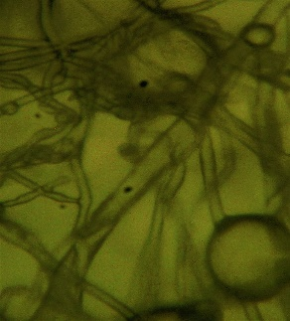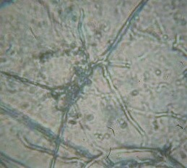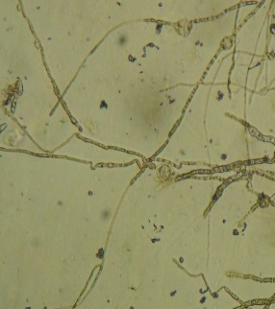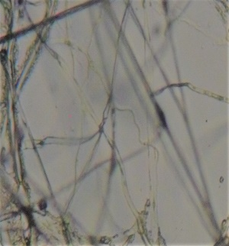
p
r
p
p
r
p
d
c
b
r
a
Figure 3. Interaction Hyperparasitic the Rhizosphere Fungi Against G. boninense. a) Isolate J5, b) Isolate J7, c) Isolate J10 and d) Isolate J12, (p = hyphae of the fungus G. boninense., r = fungal hyphae rhizosphere)

Isolates J5 in Figure 3.a have interaction in the form of attachment of fungal hyphae rhizosphere against G. boninense. This is presumably because the antagonist fungi produce enzymes which aims to degrade the cell wall of G. boninense. [13] stated that the fungus T. harzianum able to produce the enzyme chitinase, β-1,3-glucanase, β-1,4-glucanase and lipase compound that can break down chitin, glucans and lipids from the cell wall of fungal pathogens, [14] stated that the enzyme plays an important role in degrading the cell membrane to form holes in the pathogen fungal hyphae.

Interaction between J7 isolates with G. boninense. Figure 3.b namely interruption hyphae formation and cause damage to the G. boninense hyphae. This is presumably because the antagonist fungus produces a wide variety of chemical compounds that are toxic to the G. boninense. [15] reported that a group of fungi known biological agent is able to produce toxic compounds (toxic) that serves as an anti-microbial. [16] stated that the genus Trichoderma can inhibit the growth of pathogen hyphae to produce antibiotics gliotoxin and viridin.

J10 isolates have interaction against G. boninense. Figure 3.c in the form of thinning hyphae and then hyphae of pathogens to be broke. This is consistent with the results [17] which stated that the lysis mechanism characterized by changing the color of pathogen fungal hyphae become clear and empty, then there are broken and eventually destroyed.

Figure 3.d has demonstrated that isolates J12 pathogen interaction in the form of fungal hyphae that grow curl (deformation/malformation). This is consistent with the results of research [18] which stated that the symptoms caused by infection of a microbe can be discoloration and deformation.
  - Characteristics of Fungal Morphology from Oil Palm Rhizosphere which is Highly Antagonistic and Microscopic

Identification of 4 rhizosphere fungi isolates that have high antagonistic power based on macroscopic and microscopic characteristics. The results of identification of 4 rhizosphere fungi isolates refer to the book "Pictorial Atlas of Soil and Seed Fungi" [19] can be seen in Table 5, Figure 4, Figure 5, Figure 6 and Figure 7.
Table 5. Macroscopic and Microscopic Characteristics of 4 Rhizosphere Fungal Isolates of oil Palm Plants
Morphological characteristics | Isolate J5 | Isolate J7 | Isolate J12 | Isolate J10
The colour of colony | Greenish white | Greenish white | Light brown with | Brownish green with white edges
Direction of deployment | To side | To side | To side | To side
Mycellium | rough | Rough | Smooth | Rough
Microscopis:  Conidia form | round | Round | - | round
Conidiophores | Upright and branched  short phialid and thick | Upright and branched  short phialid and thick | Upright and non septate | non branched and septate
Hyphae form | septate | Non septate | Divided and non septate | non septate and hialin
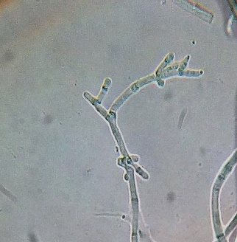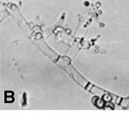
2
a
b
c
2
1
3
4
1
3
4
Figure 4. Macroscopic and Microscopic Characteristics of Isolate J5, a) Fungi colony on PDA medium, b) microscopic of fungi at magnification of a microscope 40x10, c) microscopic of Trichoderma fungi [19], (1. conidia, 2. phialid, 3. conidiophores and 4. hyfa)

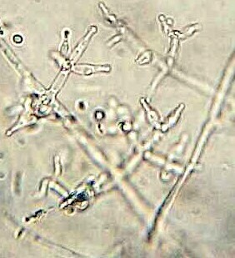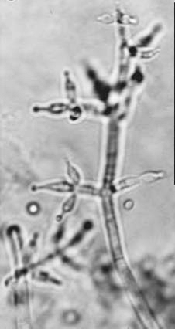
2
4
1
3
2
1
3
4
a
c
b
Figure 5. Macroscopic and Microscopic Characteristics of Isolate J7, a) Fungi colony on PDA medium, b) ) microscopic of fungi at magnification of a microscope 40x10, c) microscopic of Trichoderma fungi [19], (1. conidia, 2. phialid, 3. conidiophores and 4. hyfa)

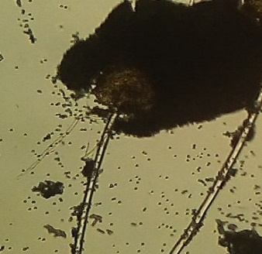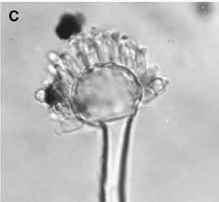
a
b
c
1
4
3
2
1
2
3
Figure 6. Macroscopic and microscopic characteristics of isolate J10, a) Fungi colony on PDA medium, b) ) microscopic of fungi at magnification of a microscope 40x10, c) microscopic of Aspergillus fungi [19], (1. conidiophores, 2. vesicles, 3. conidia, and 4. phialid)

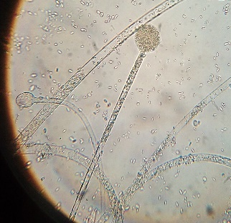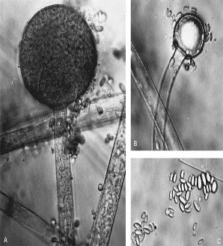
3
c
2
3
1
1
2
a
b
Figure 7. Macroscopic and microscopic characteristics of isolate J12, a) Fungi colony on PDA medium, b) ) microscopic of fungi at magnification of a microscope 40x10, c) microscopic of mucor fungi [19], (1. sporangium, 2. spores, and 3. sporangiofor)
Table 5 and Figure 4 show that isolate J5 has macroscopic characteristics: the color of the colony is greenish-white, the spread of mycelium in all directions and the shape of the mycelium is rough. Microscopic characteristics are that it has a round conidia, upright and branched conidiophores and has short and thick phialids and forms of septa and hyaline hyphae. Isolate J5 belongs to the genus Trichoderma based on the literature book "Pictorial Atlas of Soil and Seed Fungi" [19]. Trichoderma has a conidiophoric form which is developed in the structure of upright, branched vertically arranged pillows. Phialids are short and thick and conidia are smooth-walled and oval shaped.
J7 isolates from the rhizosphere of oil palm plants in peat soils have the form of coarse mycelium in PDA medium. J7 isolate colonies grew rapidly and spread in all directions. Isolate J7 has greenish-white mycelium (Figure 5), hyphae that are not insulated and hyaline, conidia are round and hyaline, conidiophores are branched and upright and have thick and short phialids. The J7 isolates correspond to the characteristics of the genus Trichoderma based on the literature book "Pictorial Atlas of Soil and Seed Fungi" [19]. Trichoderma has the characteristics of a short phialid stalk, conidia shaped globuse (round) growing at the tip. Phialid has a length of ± 11.1 µ and conidiophoric branches of ± 13.4 µ. There are many branching conidiophores that resemble pyramids, which are longer branches below, phialids arranged in different groups, there are 2-3 phialids per group.
Table 5 shows that J10 isolates had a characteristic fungal morphology, namely the presence of rounded, phialid vesicles that formed on the entire surface of vesicles and conidia that formed in a chain of phialids and hyphae that were not insulated and hyaline. J10 isolate has hyaline conidiophores, upright and thick-walled and not insulated. The colonies on the PDA medium are brownish black with white edges with a slightly rough surface and spread of mycelium in all directions (Figure 6). J10 isolates are isolates that belong to the genus Aspergillus based on the results of identification from the literature book "Pictorial Atlas of Soil and Seed Fungi" [19]. Aspergillus has microscopic characteristics of conidiophores appearing unbranched from special foot cells, conidiophores enlarge at the tip, forming swollen vesicles. Texture like velvet or cotton. The opposite color of the colony is usually white, golden or brown.
Table 5 shows that J12 isolates had macroscopic characteristics, namely J12 isolate colonies on PDA medium light brown with white edges (Figure 7), mycelium spread in all directions and the shape of mycelium was smooth. Microscopic characteristics of J12 isolate have erect and pale yellow sporangiophores, oval-shaped spores and various sizes, round sporangium and hyaline. Isolate J7 is included in the genus Mucor based on identification results from the literature book "Pictorial Atlas of Soil and Seed Fungi" [19]. Mucor has white to light brown colonies. Microscopically hyphae are insulated, long, round, dark spores. The genus Mucor generally has a long sporangiospora (diameter 50-300 µm) and does not form rhizoid. Sporangiofor rather hard wall and branching. Round or rather round columna and hyaline sporangiophores.

Conclusions
Based on the results of research obtained 12 isolates from origin of the rhizosphere fungi insulation plant oil palm on peat soils with distinct morphological characters based on color and shape. Test hypovirulence on cucumber seedlings obtained eight isolates that isolates J2, J5, J6, J7, J8, J10, J11 and J12 is a fungus that hypovirulence, while isolates J1, J3, J4 and J9 is virulent. The isolates fungi potentially antagonist ie isolate 70.26% J5, 67.83% J7, J12 and J10 66.94% 63.33%. The diameter of the colony and fungus growth rate as the highest potential antagonist isolates J5 92.30 mm and 19.60 mm/day, followed by the J7 isolate 84.00 mm and 12.70 mm/day, J12 60.40 mm and 11, 50 mm/day and J10 44.40 mm and 6.10 mm/day. Type hyperparasitic each fungi potentially antagonist with G. boninense. ie J5, J7, J10 and J12. The identification results show that the J5 isolate have similarities with genus Trichoderma is a genus Trichoderma isolates J7, J12 is a genus Mucor isolates and isolates of Aspergillus J10.

REFERENCES
- Central Bureau of Statistics, “Statistics Indonesia Oil Palm Plantations from 2015 to 2017,” Directorate General of Plantation, Jakarta, 2017.
- Department of Oil Palm Plantation, “12384.85 hectares of Riau Plantation crops pests,” Antara Riau.com, 2014. [Accessed: June 11, 2017].
- A. W. Tri, M. I. Pinem and Y. Pangestiningsih, “The ability of the soil fungus Ganoderma suppressive against bon,inense on oil palm plantations”, Journal Agroecotechnology, vol. 5, no. 3, pp. 707-715, 2017.
- M. Murali, K. N. Amruthesh, J. Sudisha., S. R. Niranjana, and H. S. Shetty, “Screening for plant growth promoting fungi and their ability for growth promotion and induction of resistance in pearl millet against downy mildew disease,” Journal of Phytopatology, vol. 4, no. 5, pp. 30-36., 2012.
- Barnett and Hunter, Illustrated Genera of Imperfect Fungi: Imperfect Fungi, Minneappolis: Burgers Publishing Company, 1972.
- C. A. Worosuryani and A. W. Priyatmojo, “The ability of fungi isolated test of sand land as PGPF (Plant growth promoting fungi),” Journal Agrosains, vol. 1, no. 9, pp. 179-192, 2006.
- W. Otten, D. J. Bailey, and C. A. Giligan, “Empirical evidence of spatial thresholds to control invasion of fungal parasites and saprotrophs,” New Phytologist, vol. 163, pp. 125-132, 2004.
- S. Purwantisari and B. H. Rini, “Test Phytoptora infestant antagonist fungal pathogens causing late blight and potato tuber using Trichoderma spp. Local isolates,” Journal biome, vol. 11, no. 1, pp. 24-32, 2009.
- E. Yulianto “Evaluation of the potential of some fungal agent antagonists in inhibiting pathogenic Fusarium sp. in maize (Zea mays L.),” Faculty of Agriculture, University of Bengkulu, 2014.
- C. P. Kubicek and G. E. Harman, Trichoderma and Gliocladium: Basic Biology, Taxonomy and Genetics, Taylor & Francis e-Library. pp. 278, 2002.
- S. Fety, Khotimah, and Mukarlina, “Test antagonists local isolate rhizosphere fungi against phytophthora sp. isolated from the stem tan (Lansium domesticum Corr.),” Journal Protobiont, vol. 4, no. 1, pp. 218-225, 2015.
- B. L. Batzing, Microbiology: an Introduction. Brooks, London: Thomson Learning, inc., 2002.
- I. M. Sudarma and D. N. Suprapta, “Potential fungal antagonist derived from banana plant habitat with and without symptoms of fusarium wilt to control Fusarium oxysporum f Cubense in vitro. The Excellence Research Udayana University, pp. 161-166, 2011.
- S. Matroudi, M. R. Zamani, and M. Motallebi, “Antagonist effects of three species of Trichoderma sp. on Sclerotinia sclerotiorum, the causal agent of canola stem rot,” Egyptian Journal of Biology, vol. 11, pp. 37-44, 2009.
- M. Tambingsila, “Identify and test the effectiveness of rhizosphere fungi of cocoa plants as their potential as controlling antagonists (Phytophthora palmivora Bult.) which cause cocoa fruit rot,” Jurnal AgroPet, vol. 13, no. 1, pp. 12-23, 2016.
- D. Sunarwati and R. Yoza, “Kemampuan Trichoderma dan Penicillium dalam menghambat pertumbuhan cendawan penyebab penyakit busuk akar durian (Phytophthora palmivora) secara in vitro,” Seminar Nasional Program dan Strategi Pengembangan Buah Nusantara, 2010.
- W. Sari and E. Setiawanto, “Potential banana rhizosphere fungi as a biocontrol agent against fungus Fusarium oxysporum f.sp cubense causes banana wilt disease,” Agroscience Journal, vol. 1, no. 2, pp. 37-42, 2015.
- M. Hutabalian, M. I. Pinem, and S. Oemry, “Test antagonism test some saprophytic and endophytic fungi of banana against Fusarium oxysporium f. sp. cubens in laboratory,” Jurnal Online Agroekoteaknologi, vol. 3, no. 2, pp. 687-695, 2015.
- T. Watanabe, Pictorial Atlas of Soil and Seed Fungi, Edition 2th. USA: CRC press, 2002.

