Implementation of Finite Element Method for Structural Analysis of Bridge Resistance
Erwin^{1*} and Joni², J.L. Marpaung¹
¹Mathematics Department, Universitas Sumatera Utara, Medan, Indonesia
²IT Department, STMIK TIME, Medan, Indonesia
Abstract. The bridge problem is one of the structural phenomenon in physical structural analysis. One of the problems of the bridge is how to analyze the fatigue of the bridge model so that the resistance of the bridge may be estimated. In this paper the bridge problem will be explained using the Finite Element Method in displacement function analysis. The stress-strain number will be written in the parameters of the bridge model. the displacement function is clearly influenced by the stress-strain value so that the initialization of the initial value will follow the value of the specified parameter. In this paper the displacement function of the bridge will be explained in a simulation model. The result of this research is the difference between the initial model to the simulation model so that the resistance of the model can be analyzed as the cause of the initial parameters.
Keyword: Bridge Problem, Dispalcement Function, Finite Element Method, Simulation
Abstrak. Masalah jembatan merupakan salah satu fenomena struktural dalam analisis struktur fisik. Salah satu permasalahan jembatan adalah bagaimana menganalisis kelelahan model jembatan sehingga dapat diperkirakan ketahanan jembatan. Dalam makalah ini akan dijelaskan permasalahan jembatan dengan menggunakan Metode Elemen Hingga dalam analisis fungsi perpindahan. Jumlah tegangan-regangan akan ditulis dalam parameter model jembatan. fungsi perpindahan jelas dipengaruhi oleh nilai tegangan-regangan sehingga inisialisasi nilai awal akan mengikuti nilai parameter yang ditentukan. Dalam makalah ini akan dijelaskan fungsi perpindahan jembatan dalam model simulasi. Hasil dari penelitian ini adalah adanya perbedaan antara model awal dengan model simulasi sehingga hambatan model dapat dianalisis sebagai penyebab parameter awal.
Kata Kunci: Permasalahan Jembatan, Fungsi Perpindahan, Metode Elemen Hingga, Simulasi
Received 01 June 2021 | Revised 02 August 2024 | Accepted 30 September 2021
- Introduction
A bridge is a physical structure that serves as a connecting road from one point to another. The bridge has the load-bearing properties given by users, therefore, the optimal bridge construction will give good results in terms of crossing. The bridge problem is a phenomenon about structural analysis that can be studied by understanding the model and the analysis of the constituent materials, the difference between the arrangement and the model will affect the durability and quality of the bridge. Based on the constituent materials, bridges can be divided into 5 types, namely bridges made of wood, stone, concrete, steel, and composites [1]. Informing the bridge model, it is necessary to carry out an in-depth analysis of the contours of the location so that it can be adapted to the bridge model to be formed. The problem of structural analysis can be studied more deeply by using the finite element method where the building structure will be converted into simpler elements so that each element will provide a force value so that it can be assumed that the force received by an element will affect the amount of force received for each element. other elements. In this study, the author will focus on the formation of a bridge model and will simulate the resistance of the bridge by applying a load if the bridge is to be passed.
- Finite Element Method
The Finite Element Method (FEM) is one of the numerical disciplines that focuses on structural analysis with the principle of dividing a complex problem into simpler elements and then calculating the solution of each element. The principle of FEM is to determine the matrix value of each element for each coordinate of the polar form [1]. The finite element method focuses to solve the displacement function to the bridge model. The displacement function for the horizontal and vertical problem are respectively of node $i$. The strains components are.
$${ ε}_{x}=\frac{∂N_{i}}{∂_{x}}u_{i}+ \frac{∂N_{j}}{∂_{x}}u_{i}+\frac{∂N_{m}}{∂_{x}}u_{i}$$  $${ ε}_{y}=\frac{∂N_{i}}{∂_{y}}u_{i}+ \frac{∂N_{j}}{∂_{y}}u_{i}+\frac{∂N_{m}}{∂_{y}}u_{i}$$  $$γ_{xy}=\frac{∂N_{i}}{∂_{y}}u_{i}+ \frac{∂N_{j}}{∂_{y}}u_{i}+\frac{∂N_{m}}{∂_{y}}u_{i}+\frac{∂N_{i}}{∂_{x}}v_{i}+ \frac{∂N_{j}}{∂_{x}}v_{i}+\frac{∂N_{m}}{x}v_{i}$$ | (1)
In stress analysis, Eq. (1) can be written in matrix element by the Hooke’s Law, the stress component in each element may be expressed by
$$\left\{σ\right\}=\left\{\begin{matrix}σ_{x} \\ σ_{y} \\ τ_{xy}\end{matrix}\right\}=\frac{E}{1-μ}\left[\begin{matrix}1 & μ & 0 \\ μ & 1 & 0 \\ 0 & 0 & \frac{1-μ}{2}\end{matrix}\right]\left\{\begin{matrix}ε_{x} \\ ε_{y} \\ γ_{xy}\end{matrix}\right\}=\left[D\right]\left\{ε\right\}$$ | (2)
The strain model is expressed by the displacement function of the node element, the nodal displacement may also be expressed as
$${\left\{F\right\}}^{e}={\left[K\right]}^{e}{\left\{δ\right\}}^{e}$$ | (3)
The displacement function of the nodal element refers to the multiplication of the stiffness matrix in $\left[K\right]$ and the inverse of the previous formula for nodal displacement [2]. The $δ$ value may also be expressed as
$$δ={\left[K\right]}^{-1}\{F\}$$ | (4)
The finite element method possesses the superiorities as
1. The original problem is impossible to solve by manual solution, so it needs a computers solution to provide the solution.
2. The finite element method generally be used to solve the optimal solution in engineering problems and complex structural.
3. Different materials may be used for different elements.
4. The nonlinear may be calculated, including material nonlinearity and geometrical nonlinearity problems.
- Newton Method
Firstly, consider the nonlinear equation of the single variable $x$:
$$f\left(x\right)=0$$
Remind the linear terms, it makes the Taylor expansion at $x_{0}$ and gets the linear approximate equation of $f\left(x\right)=0$ near to $x_{0}$ to obtain
$$f\left(x_{0}\right)+f^{'}\left(x_{0}\right)\left(x-x_{0}\right)+{…+f}^{n}(x_{m})(x_{n}-x_{m})$$ | (5)
If $f\left(x\right)≠0$, the solution for the above equation is
$$x_{1}=x_{0}-\frac{f(x_{n})}{f'(x_{n})}$$ | (6)
- Strain-Stress Modelling
The optimal Bridge model is providing the stiffness value by the material. The principle of Bridge Model Analysis is to simulate the bridge model [2]. The virtual strain energy of the whole body is
$$δU=\iiint{{\left(ε^{*}\right)}^{T}\left\{σ\right\} dx dy dz}$$ | (7)
The virtual displacement principles demonstrate that if the body is in equilibrium before virtual displacement occurs, the virtual work done by external for at the time of virtual displacement occurring is equal to the virtual strain energy of the body, $δV=δU$, can be expressed
$${\left\{δ^{*}\right\}}^{T}\left\{F\right\}=\iiint{{\left\{ε^{*}\right\}}^{T}\left\{σ\right\} dxdydz}$$ | (8)
Because of the virtual strain Eq. (8), the strain energy caused by the stresses within the body is
$$δU=\iint{\left\{ε^{*}\right\}\left\{σ\right\}dxdy}$$  $=\iint{\left[σ_{x}\frac{∂u^{*}}{∂_{x}}+σ_{y}\frac{∂v^{*}}{∂_{y}}+τ_{xy}\left(\frac{∂u^{*}}{∂_{y}}+\frac{∂v^{*}}{∂_{x}}\right)\right]}dxdy$ | (9)
As
$$\iint{\frac{∂(σ_{x}u^{*})}{∂_{x}}}dxdy=\iint{u^{*}\frac{∂σ_{x} }{∂_{x}}dxdy+\iint{σ_{x}\frac{∂u^{*}}{∂_{x}}dxdy}}$$ | (10)
So, the first term on the right part of the Eq. (9) is
$$\iint{σ_{x}\frac{∂u^{*}}{∂_{x}}dxdy=\iint{\frac{∂(σu^{*})}{∂_{x}}}}dxdy-\iint{u^{*}\frac{∂σ_{x}}{∂_{x}}dxdy}$$ | (11)
- Simulation Bridge’s Model
  - Global Geometry
The Bridge model is used to represent the displacement problem in the bridge [3], the element of nodal is simulated by the COMSOL Multiphysics with the parameters as the original ratio.
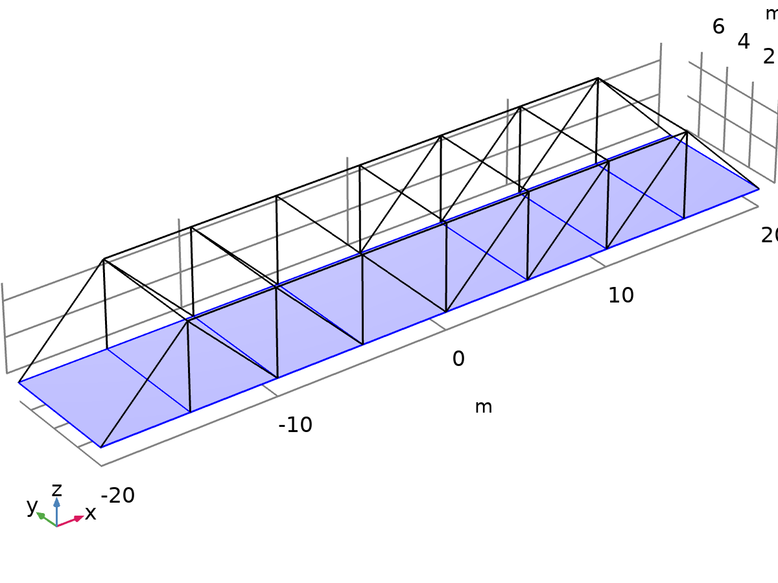
- Bridge Design in Parameters
  - Mesh Model
Global geometry generally needs to mesh each element for pre-processing the simulation, the mesh model can be represented in Figure 2.
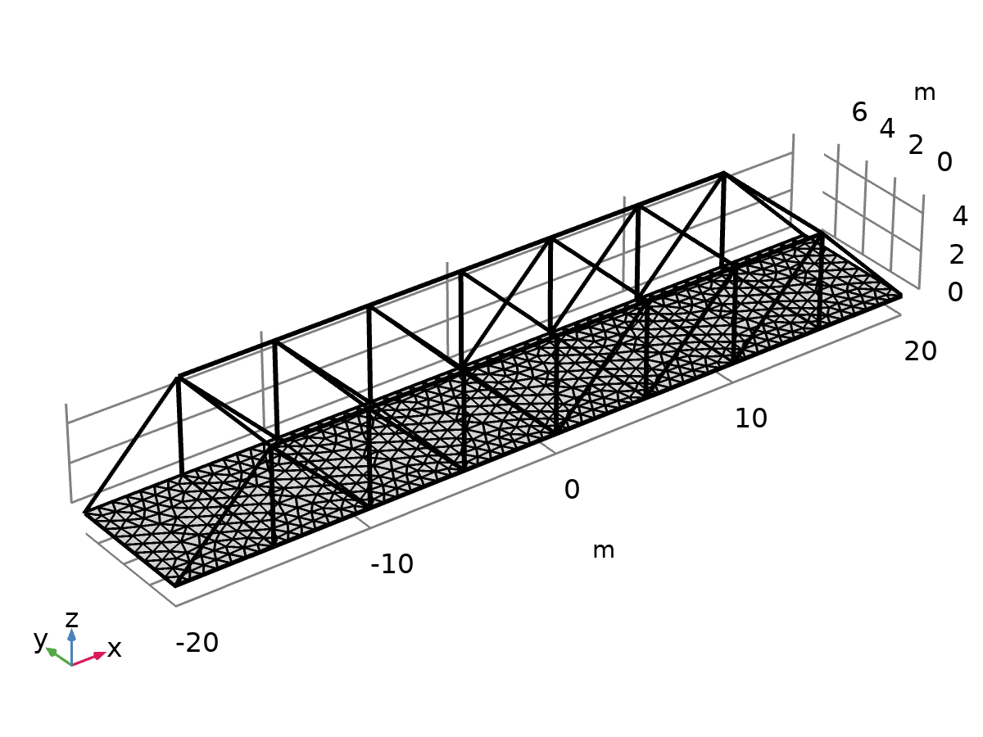
- Bridge’s Mesh

Shell-beam connection in bridge’s mesh show the equation of the connectivity.
$$u_{b}=u_{s}+\left(d_{0}.n\right) on ∂ Ω_{c} \\ θ_{b}.t_{1}=-ar.t_{2} on ∂ Ω_{c} \\ θ_{b}.t_{2}=ar.t_{1} on ∂ Ω_{c} \\ θ_{b}.n^{0}=\left(n^{0}×n^{1}\right).ar^{1} on ∂ Ω_{c.foldline} \\ ∂Ω_{c}=∂Ω_{s}∩∂Ω_{b}$$
  - Torsional Orientation
The study about the displacement model may also show the torsional orientation in the model, The coordinate $(x,y)$ explains how the displacement function works in 2-Dimensional. Figure 3 (b) explain about beam tensional caused of the displacement function.
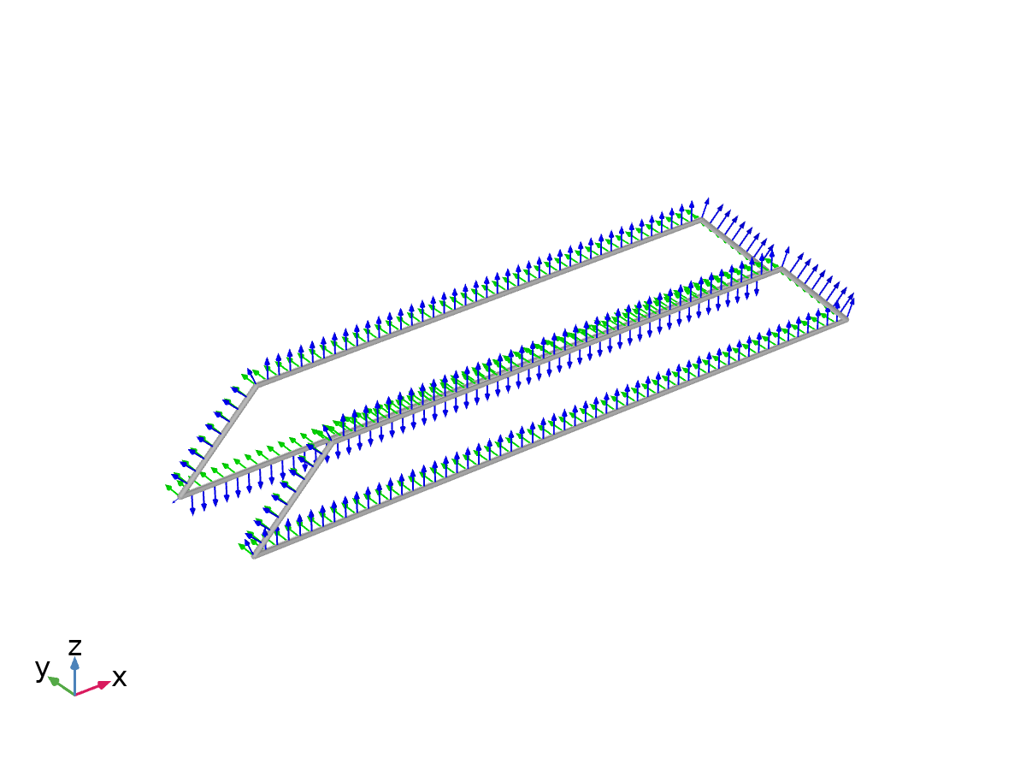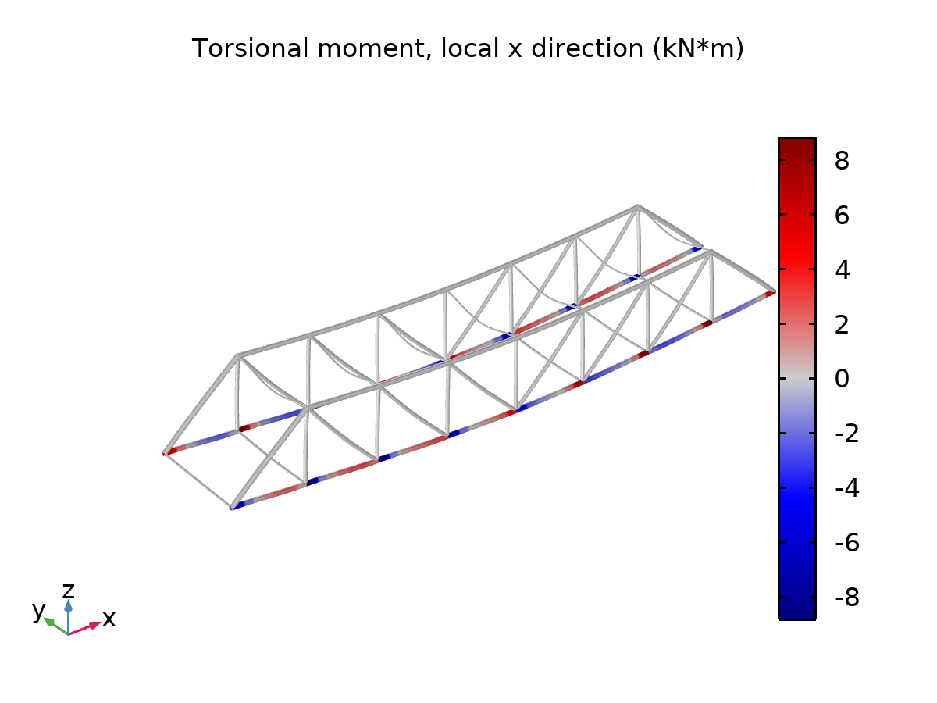
- (b)
- Torsional Orientation in Bridge
Finally, the displacement simulation can be represented by the Figure 3.
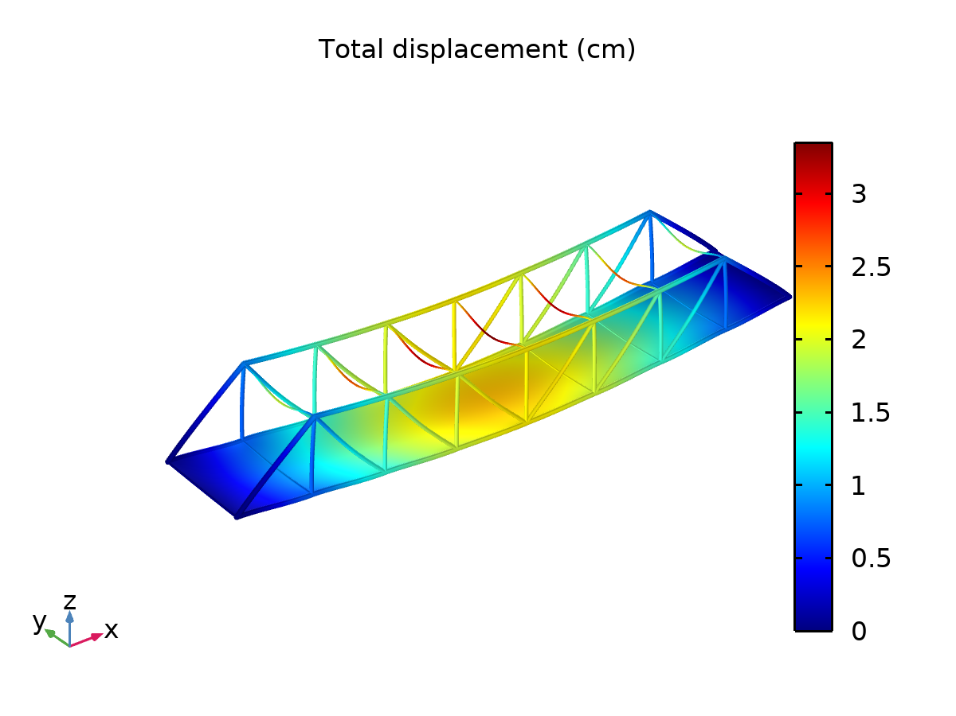
- Displacement Simulation in Strain-Stress Model
The color indicator above represents the amount of load received by the bridge. the results of the simulation show that the point that receives the greatest force is at the point in the middle so that the center point shows a bright yellow color. Changes in the shape of the structure are influenced by the pressure received for each element so that it can result in a change in overall shape. The displacement function maps the value $δ_{xy}$ in each element so that it will affect the change in the shape of a structure. For the problem of the bridge model in this study, the bridge experiences a position displacement from its equilibrium point so that the magnitude of the displacement value will be directly proportional to the elasticity value of the bridge, if the bridge receives a load exceeding the maximum elastic capacity, the bridge will experience fatigue and even damage. The eigenfrequency shows the effective modal mass that bridge can receive in displacement value for Z-translation.
- Eigen Frequency Simulation
Eigenfrequency (Hz) | Frequency (Hz)
2.9853 | 2.9853
3.4740 | 3.4740
3.7375 | 3.7375
4.4371 | 4.4371
5.2131 | 5.2131
5.2183 | 5.2183
5.2367 | 5.2367
5.2403 | 5.2403
5.2434 | 5.2434
5.2477 | 5.2477
5.2496 | 5.2496
5.8286 | 5.8286
- Comparison Eigen Frequency – Effective Modal Mass
Eigen frequency (Hz) | Effective modal mass, Z-translation (kg)
2.9853 | 6.6372E-5
3.4740 | 0.0020314
3.7375 | 1.4475E5
4.4371 | 1.0626E-4
5.2131 | 0.30264
5.2183 | 442.15
5.2367 | 0.064365
5.2403 | 49.674
5.2434 | 776.33
5.2477 | 1.6602
5.2496 | 77.389
5.8286 | 2.7432E-5
- Conclusions
The result of this research is the difference between the initial model to the simulation model so that the resistance of the model can be analyzed as the cause of the initial parameters. From Table 2, it is noted that the higher the Eigen frequency, the more effective it will be.
References
[1] Tulus, J. L. Marpaung, T. J. Marpaung, and Suriati, “Computational analysis of heat transfer in three types of motorcycle exhaust materials,” J. Phys. Conf. Ser., vol. 1542, no. 1, 2020, doi: 10.1088/1742-6596/1542/1/012034.
[2] T. Wang, J. Qiu, W. Luo, and J. Zhang, “Based on the two-dimensional air resistance bridge crane anti-swing control research,” Procedia Comput. Sci., vol. 183, pp. 175–181, 2021, doi: 10.1016/j.procs.2021.02.047.
[3] A. J. Reis and J. J. O. Pedro, Bridge Design Concepts and Analysis, vol. 53, no. 9. 2019.

